A monthly publication
of the Missouri Valley & Modale
United Methodist Churches.
The M & M Messenger

August 2018

I thought I’d use this article to introduce ourselves to you and let you know a little bit of information about us. Jennifer and I have been married 19 years and we have 5 wonderful children: Evan is 16, Will is 14, Hannah is 10, Abigail is 8, and Micah is 3.
Prior to coming here to Missouri Valley and Modale, I served for 5 years in Sidney, IA, at United Faith Church (a UMC-Presbyterian Church (USA) merged congregation). Before that, I served 3 United Methodist churches near Oskaloosa, IA for 5 years, was the Campus Minister at Iowa Wesleyan College for about 2 years and served 2 United Methodist churches near Sioux City for over 3 years. I received a Master of Arts in Religion from the University of Dubuque Theological Seminary in May of 2000 (a 60 hour degree), but later needed some more coursework to become an ordained elder in the UMC, which I completed at Sioux Falls Seminary.

I have an older brother and younger sister. I grew up in Council Bluffs, IA, so I am familiar with this area. While I was in college, my parents moved to Clarinda, IA, where they still reside.

Jennifer is the oldest of 3 children, and grew up in several places in Minnesota, as her father is a retired UMC pastor. After retirement, they moved to Branson, MO.

We are looking forward to getting to know you all. I am excited to be serving as your pastor, and being in ministry with all of you, as we minister together for the Kingdom of God. My prayer is that God will richly bless each one of us, so that we might in turn be a blessing to others and that we might share with others the Good News of Jesus’ death and Resurrection, and the salvation, forgiveness, and healing that is found in Jesus.

Serving in the power of the Risen Christ
Pastor Jason and family

Missouri Valley UMC Modale UMC
308 E. Superior 108 E. Haley St.
Missouri Valley, Iowa 51555 PO Box 95
Modale, Iowa 51556
712-642-3168: office Church office hours:
712-642-2464: kitchen 9 am to 11:30 am
Monday, Wednesday, and Friday

Happy Birthday

Aug 2nd Connie Crispin
Aug 4th Cathy Jones
Aug 7th Michael Brown
Aug 8th Cassandra Warner
Eldon Warner
Aug 9th Gene McCurley
Aug 10th Ellie Kohl
Rod Ortner
Aug 13th Kathy Burress
Aug 16th Grace Hankins
Betty Pike
Andrew Stevenson
Aug 18th Marge Sass
Aug 19th Joni Neese
Ruth Utman
Aug 22nd Meagan Gochenour
Dawn Fichter
Aug 23rd Gunnar Lamb
Aug 25th Cole Lange
Aug 28th Lydia Rankin
Aug 29th Shelly Brown
Diane Hoyt
Jason Kleinmeyer

Happy Anniversary

Aug 1st Andrew & Hillary Stevenson Aug 6th Dan & Bev Hutchinson
Aug 6th Doug & Katie Cooper Aug 7th Joe & Sue Cathcart
Aug 8th Jeff & Cheryl Smithson Aug 15th Steve & Shirley Baker
Aug 21st Greg & Marianna Anderson Aug 23rd Cathy & Fred Ebert
Aug 29th Gene & Carole McCurley Aug 30th Larry & Trisha Jones

We are always updating our “Birthday” and “Anniversary” list. If we are missing a birthday or anniversary, need to make a correction, or if you would like to add one to our list … please email the central office at … moumcmvumc@gmail.com

Matthew 25:23
"The master said, 'Well done, my good and faithful servant. You have been faithful in handling this small amount, so now I will give you many more responsibilities. Let's celebrate together!'

I would like to take this opportunity to express my thanks and appreciation for a job well done. Thank you so much for your labor of love with the parsonage repairs and clean-up.

Your willingness to use your gifts and abilities has strengthened the mission and ministry of this church and helped to provide a safe and comfortable home for our Pastor and his family. You have also been an example of servant-leadership and giving. For all your time, effort, hard work, and prayers, please accept the thanks and appreciation of this church, its leaders and staff, and me.

You have truly been a blessing to this congregation! “Well done, good and faithful servant.”

With Sincere Gratitude,

Missouri Valley & Modale SPPRC Chair - Kim Bentsen
Thank you for the many birthday cards that I received for my
93rd birthday. It was a nice surprise.
Birdell Stirtz

Thank You from the mission committee. Ray reported that $180.63 was recently taken from the mission cross.

Deb and Scott Davey continue to heal and improve. Talk of going home is in the wind.

Thanks for all who have stepped up to help with mowing at their home. Please continue to remember them in prayer. God is working miracles!

Oh no…I made a mistake, omission…Carla Christensen, who has been with “All4U” since the beginning, was not listed in the newsletter by their picture. ☹ I’m sure that was my error. Sorry…... Ruth Utman

UPDATE IN LIEU OF FAIR FOOD STAND
The fundraising project “In Lieu of Fair” is coming right along in July. We have raised over $1600 as of July 22nd and still have a couple of weeks before we close out in August.
We are asking for contributions equal to all the work Cooking, Cleaning, Shopping, Pie baking, and Serving and running around that you did at the Fair in prior years. I am sure we will all miss the long hours and fellowship we had working the fair stand at the fair! This fundraising project is targeted to producing $3,500 to $4,000 in revenue for the church’s annual budget

We ask that you mark your contributions “IN LIEU OF THE FAIR”.
Thank you for your generosity and support.
Mo Valley Finance Committee

A reminder that alter flowers may be ordered from either MJ’s Flowers or Minnie Fisher’s flowers. Each flower shop delivers to the church on Saturday mornings. The flower calendar is in the back of the sanctuary.

Read & Feed
The Read & Feed program is in full swing. The number of students attending has recently grown. We still need adult helpers to prepare the food. If you would like to contribute your time, let Sue or Angie know. If you would like to contribute some funds for the purchase of the foods, that would be great too. We will be ending this service as soon as school starts. Thank you for helping with this community service.

The Modale United Methodist Church held it’s one-day Vacation Bible School “Surf Shack” on Friday, July 13th with a program during worship on Sunday, July 15th. With 37 kids and 23 volunteers, a lot of fun was had by all while learning about the Baptism of Jesus, singing songs, doing crafts & playing games PLUS snacks and a great lunch of Linda’s “world famous” goulash. We thank God that he gave us these precious children for a day and invite them to join us for more adventures every Sunday.

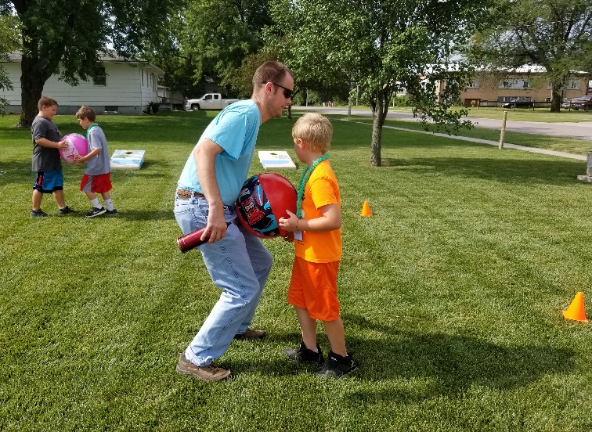
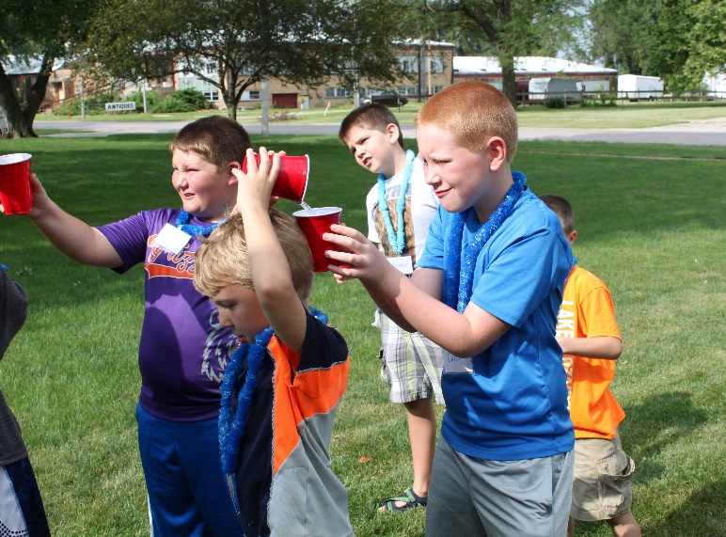

Games Pastor & Justin
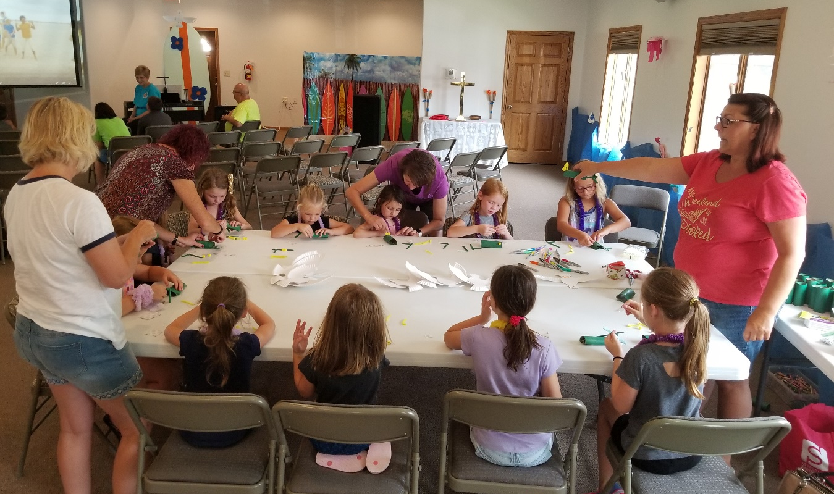

Crafts

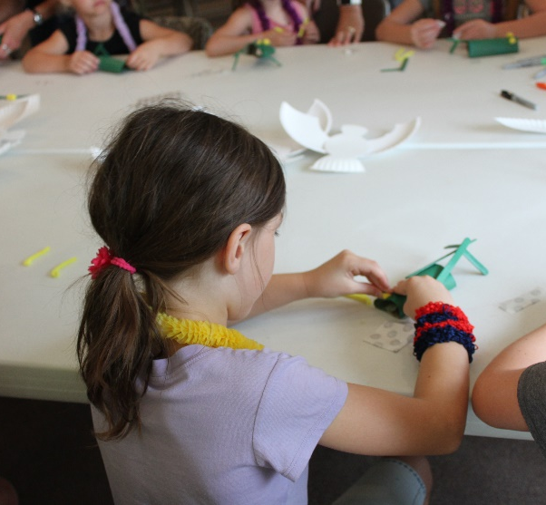

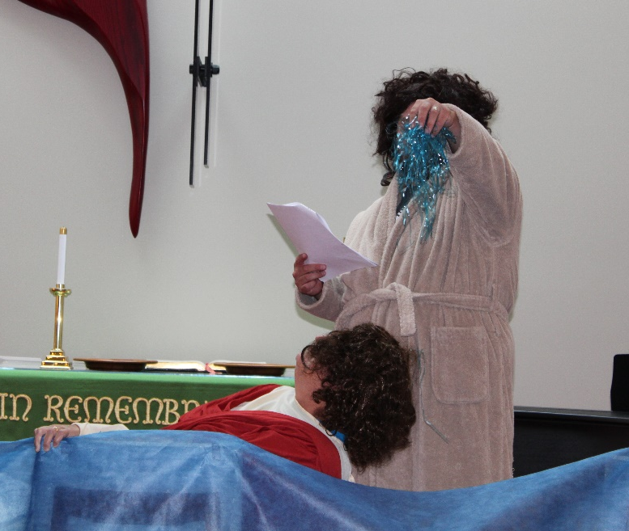
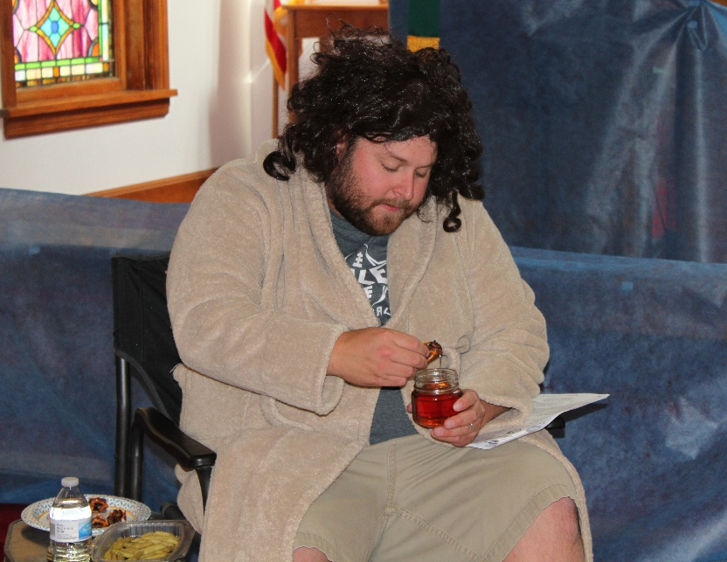
Andrew Stevenson – John the Baptist (NOT John the Dentist) eating locust & honey John (Andrew) baptizing Jesus (Kim)
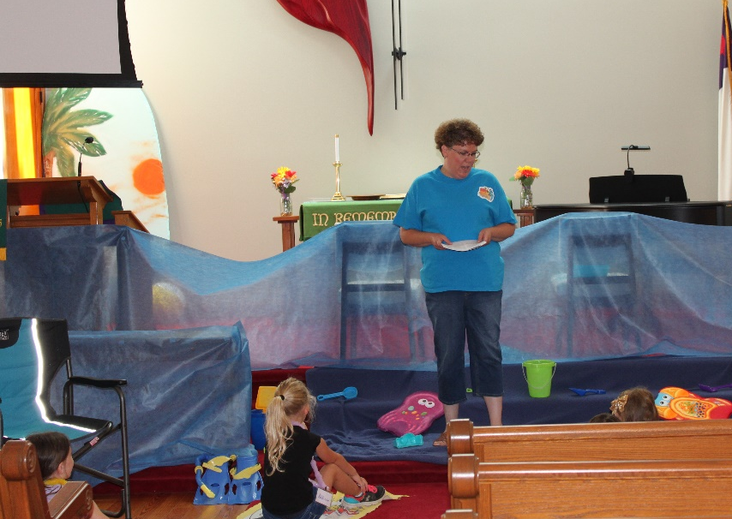

Katie Cooper starting lesson

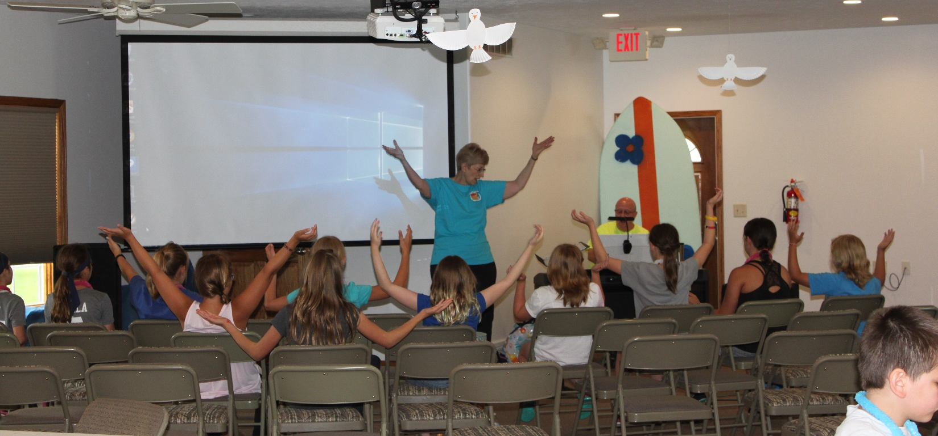
Bev & Dan – Music/Tidal Waves

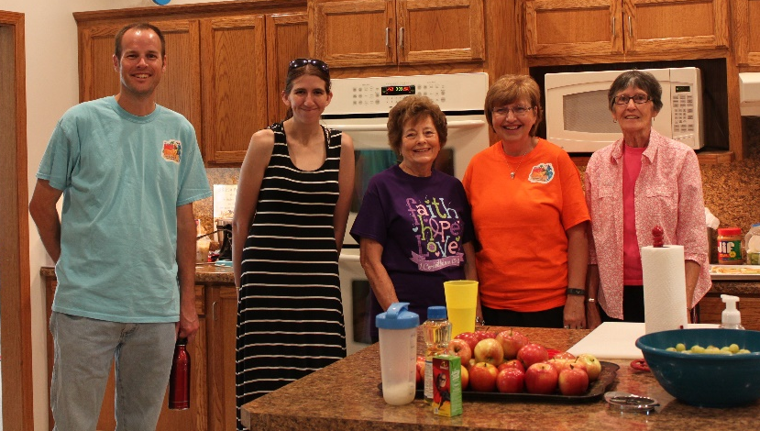
Lunch Prayer

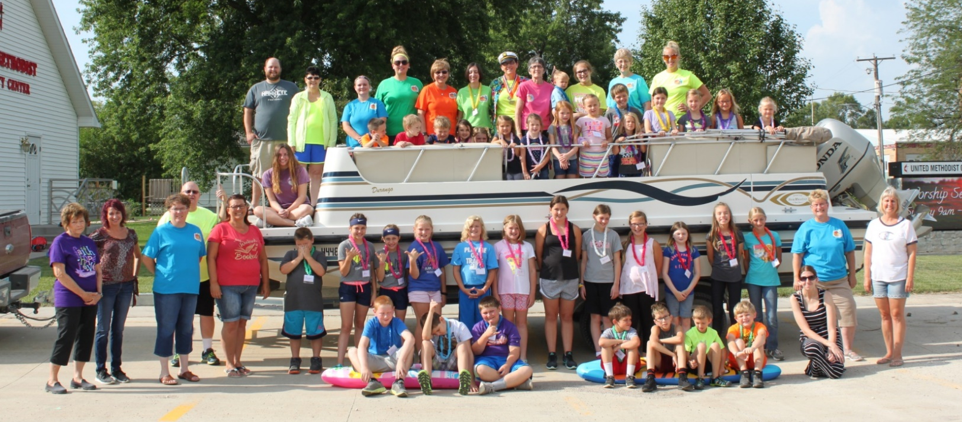
Kitchen help
Pictured are all the participants, except those taking the picture. ☺
Thank you to all our volunteers…those that participated that day and those who brought food or offered support through finances or strong backs. It is all very much appreciated! It could not happen without you ALL!!! We are truly a T.E.A.M. (Together Everyone Achieves More)

Thanks again! Ruth Utman, VBS Director
August 29th 11-1:30pm in Mo Valley
UMW sponsored luncheon and visit from Doug E. Williams
Serving At: Evangelical Methodist Church of Argentina
Location: Argentina, Latin America and the Caribbean
Home Country: United States of America, North America

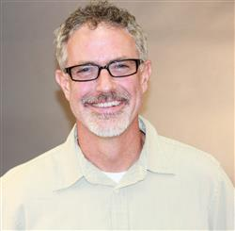
The Rev. Douglas E. Williams is a missionary with the General Board of Global Ministries of The United Methodist Church, serving as pastor and Volunteer-In-Mission promoter of the Evangelical Methodist Church of Argentina, based in Buenos Aires. He was commissioned in October 2015.
The Argentine church has 100 congregations spread across the country. Doug is pastor of the Mendoza and San Juan churches, chaplain at Alberto Schweitzer School, and assists with the hosting of VIM teams, mostly from the United States.
Doug, who was born in Virginia, is an elder of the Iowa Annual Conference and immediately prior to his missionary service was lead pastor of the Coralville United Methodist Church and an adjunct professor at Kirkwood Community College, Iowa City, Iowa. Earlier, he pastored churches in the Iowa and Tennessee Annual Conferences. He holds a Bachelor of Arts degree from William Jewell College, Liberty, Missouri, and a Master of Divinity degree from Midwestern Baptist Theological Seminary, Kansas City, Missouri, and a Doctor of Ministry degree from University of Dubuque Theological Seminary, Dubuque, Iowa.
“I grew up loving Jesus but not going to church much,” Doug recalls, but he attended enough to be baptized at age 16 in a Baptist congregation. He experienced a call to ministry while on a mission trip to Haiti during his college years and enrolled in seminary after college graduation. He transitioned to The United Methodist Church and served as a pastor for 21 years. He says that the faith communities he has served have been concerned with innovative ministries, including a coffee house, ecumenical food pantry, and a preschool.
Mission trips—both as participant and organizer—have played major roles in his ministry, including service in Mexico, Guatemala, Haiti, Native American reservations, and tornado and hurricane cleanup in the United States. A major rebuilding project at the Coralville church made it impossible for him to take part in mission trips for a number of years. God implanted in him a call to mission during that period.
“In that absence,” he says, “I recognized that God was growing a deep longing to serve outside of the country…. God seemed to be saying, ‘Now is the time.’”
On the challenge of mission, he states: “Our world is becoming a global community and God wells up in me the desire to be part of seeing God’s peace expand and renewal take place. There are so many challenges that face us and time and time again God reveals in every challenge an opportunity for growth and healing.”
Doug has two adult children, Samantha and Jonathan.

Fareway tickets
We now have 57,492 in tickets to redeem but have a lot go, so keep bringing them in and I will keep totaling them and hopefully we can reach the right amount.
Marge Stirtz
Items needed at the Harrison County food bank are:
Laundry soap, canned fruit, all cereals, diapers size 5 & 6, boxed dinners like Hamburger Helper, pork & beans, shampoo. Any cleaning supplies or paper products too. The pantry could also use your clean plastic grocery sacks. Cash is always welcome.
The food pantry is open on Tuesday and Fridays from 9am – noon

Worship Attendance & Finance Report

The financial figures only reflect the amounts received through the weekly offering and EFT (electronic fund transfer) giving. To meet our ministry and operating budget…at Modale: $1,166/week…at Missouri Valley: $1,900/week. Thank you for your participation and your generosity. A= Adults, Y= Youth
Modale UMC
July 8th 34 adults 14 Students $792.25 General Budget
$ 41. Food pantry
July 15th 37 adults 19 students $ 573.
$ 50. One Great Hour
$ 50. Golden Cross
July 22nd 35 adults 16 students $ 368.
Missouri Valley UMC
July 8th $ 1942.00 General Budget
$ 20, missions
$ 130. Christmas in July
July 10th Electronic Funds Transfer $2090. General Budget
$ 85. Capital improvements
$ 275. Apportionments
$ 793.63 from Modale
July 15th $1324.
$ 20. Missions
$ 5. Food pantry
$ 665. Christmas in July
$100. Lieu of fair stand
July 22nd 49 adults 6 students $1099.
$ 100. Apportionments
$ 240 Christmas in July
$ 500. Lieu of fair stand

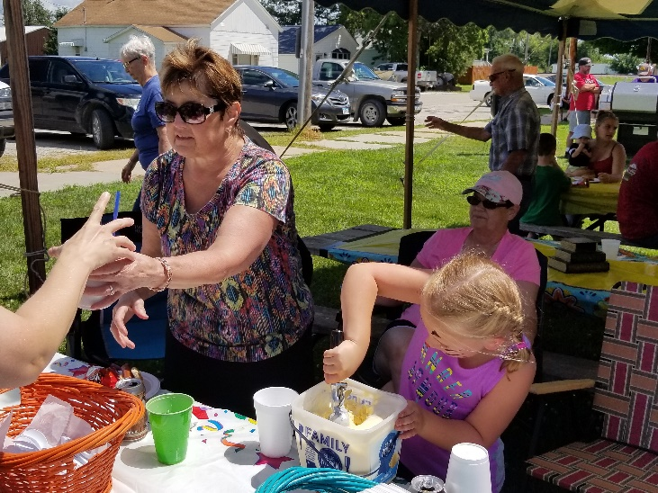

Modale United Methodist Church helped the Modale celebrate their 90th birthday, on Sat., July 14th, by serving up Root Beer Floats donated by Community Bank.

Pictured are Lorraine Peterson & Payton Stevenson

Modale United Methodist Church
Administrative Council Minutes
July 17, 2018

The Modale United Methodist Church Administrative Council was called to order by Brit, at 7:05 PM. Pastor Jason gave an opening prayer. 7 members were present. (Shirley Baker, Kim Bentsen, Pastor Jason Gutzmer, Dan Hutchinson, Brit Liljedahl, Rick Ruffcorn,& Ruth Utman)

Kim moved, 2nd by Shirley to approve the minutes as read of the 6/19/18 meeting. Motion approved.

Leadership:
- Pastor – Pastor Jason has had a funeral and visited a few church members.
- Lay Leader – Ruth and Pastor Jason will visit about the expectations of the Lay Leader role in worship or other areas. It will be an ongoing process.
- Council Chair – Brit welcomed Pastor Jason and thanked him for jumping right in on the Sunday before he had even moved to MV. Brit reviewed the EMB calendar. Revisions were made and Kim will get those to David. Church on the Green is set for September 9th at 9 am. Pastor Appreciation Sunday will be October 28, 2018. Brit reported the Music in the Park was well attended and everyone had a blast.

Worship:
- Committee Chair – Dan stated there will be a meeting soon.
- Communion Steward – Shirley and Pastor worked out the communion process. Pastor will administer communion, Shirley will assist. When Shirley is absent, she will ask someone to take her place.

Community:
- Missions – There was some discussion on the Family Fare receipts and how it is handled. Cecile will be contacted to get more information.
- Evangelism – Pam Schwertley has volunteered to fill in for Debbie until Debbie is able to resume her duties. Sharon Johnson will also be helping with the Baby bags.
- United Methodist Women – Carpets in the church are being cleaned so the meeting tomorrow night will be at the Modale Library 7:00 pm.

Education:
- Christian Education/Sunday School – Sunday School will begin September 16th.
- VBS – Ruth reported that VBS was well attended. 37 youth and 23 adult volunteers (fed an additional 12 parents). Ruth will get some of the youth together to hand out the water bottles after Fair. She will be getting the children’s pictures and a T-shirts mailed to them along with a message when Sunday School begins. Brit moved, 2nd by Dan to continue to have a one day VBS next year on Friday, July 12, 2018. Motion approved.
- Camping – Ruth reported that Payton Stevenson attended a 2 day camp at Lake Okoboji United Methodist Church Camp.

Finances:
- Treasurer’s Report - Dan handed out the treasurer’s report for 6/1/2018 – 6/31/2018. Ruth moved, 2nd by Shirley to pay $503.06 to Dan for Annual Conference expenses. Motion approved. Brit moved, 2nd by Kim to pay $700 to the Parsonage Fund in MV – the yearly amount agreed upon by both church councils. Motion approved. (See attached to these minutes.)
- Financial Secretary - Shirley discussed a hand-out of giving for the month of June 2018. Shirley added a donation to Peace With Justice that was to be included in the May 2018 report. (See attached to these minutes).
- Finance Committee – Will meet soon.

Administration and Organization:
- SPPRC – Kim reported that the committee is organizing the Welcome lunch for the Gutzmer Family on Sunday, July 22nd at noon. MV and MO UMCs are working together to have a float in the Harrison County Fair Parade on July 28, 2018. We will be meeting in MV at the Willow Park Storage Units on Monday, July 23rd at 7 pm to decorate a boat that will be used in the parade. Our theme is “Fishers of Men”. We will hand out Goldfish crackers with a sticker that states who we are.
- Trustees – Rick asked Pastor to give the committee his thoughts on having an office space in the Modale UMC. We have many ongoing projects outside.
Other Items/General Discussion:
- Brit read a Thank you from the Modale Development Corporation for the donation from the Modale UMC Missions.
- Brit thanked all that helped at the 90th Anniversary and Building Fund Kickoff. People from the Modale UMC helped serve root beer floats that the Community bank provided – it was well attended.

Next meeting will be Tuesday, August 21, 2018 7:00 pm
Closing Prayer by Pastor Jason.
Adjourned: Shirley moved, 2nd by Kim to adjourn. Motion approved. Adjourned at 8:20 pm

.

Leah Millikan of the Modale United Methodist Church was named Harrison County Fair Queen on Mon., July 23rd. She is the daughter of Stephanie & Shawn Millikan.

Congratulations Leah!!!

Missouri Valley United Methodist Church
Administrative Council Minutes

The July 16, 2018 meeting of the Missouri Valley Administrative Council was called to order at 7:02pm by Chm. Don Aronson. Members present were Don, Kathy Winther, Gary Murphy, Greg Anderson, Denise Paben, Ray Pike, Pastor Jason Gutzmer, and Angie Aronson.
Agenda additions –
Church members are encouraged to speak to the committee chairpersons, or the pastor or an SPPRC committee representative before presenting an issue at an open administrative board meeting.
After discussion, Denise made a motion to post the agenda for the ad board meeting on the Sunday before the scheduled meeting. When a church member wishes to be heard at a council meeting, add the name and contact information to new business. This will be reviewed and added to the agenda if deemed appropriate. The motion was seconded by Kathy and passed.

Opening prayer was given by Pastor Jason.
Minutes of the previous meeting were reviewed. Greg made the motion to approve the minutes as published and Ray seconded it.

Old Business – 1. Christmas in July. -Angie stated she is pleased with the response so far. Thank you to those helping.
2. Newsletter delivery – In January, 200 newsletters were being printed and sent. After the three acting office administrators have added and subtracted to the mailing list, and 22 households are now receiving their newsletter via email, the numbers have changed to 150 were printed, saving paper and copying costs. More members receiving their newsletter via email will help reduce costs even more.
3. Church key location -Angie handed out a current list as to the location of many of the church owned keys. The question was raised about continuing the search. It was decided that the office administrators will continue to keeps records of the keys and maintain a log and update the sign-in sheets. It was also suggested to relocate the office key from the fire extinguisher “hiding” spot.
4. Read and Feed – meals have been provided weekly for students, with a fluctuating attendance of 0-12 per day. It is becoming difficult to find adult volunteers and the program may wind down before the start of school. This will be determined by the adults doing the work. More publicity or a different location were suggested to aid attendances.
5. Evacuation plan – none has been located, so the trustee committee will be directed to develop a plan.
6. Foundation finalization – waiting to restart this work with Greg and Don Brothers.

Pastor – Pastor Jason stated that the family is getting settled. He has already done two services, a funeral, and an Omaha visit. He has not decided on his day off, he will meet with the secretaries and still be getting his bearings.

Council Chair – Don stated the he feels our congregation has been struggling for good leadership since Krambecks’ left. We need to educate the adults in leadership as the purpose and goals. His idea to present each committee chairperson with a current Book of Discipline may help start this process. Don also shared a hand-out on the workings of the church council. Each member was charged with studying this paper to help us all see what work is needed.
Don is also wanting to actively have a “rebirth” of the nominating committee. There is a lot of work to do to rework our committee system.

UMW- Kathy reported a nice turn-out at the annual picnic on July 11th. The women have voted to no longer have evening meetings. The schedule will continue as planned, just meet at 1:30pm. The next meeting will by August 8th in the UMW room and Connie Livermore will host. The group will also be planning a pastor appreciation Sunday in the fall.

SPRC- Denise reported that there will be a welcoming luncheon following Sunday services on the 22nd. The meal will be in Modale, Jim O’Neill is supplying the beef, Greg will cook, and we will all get to know the pastor and his family better.
There will be a combined church float for the fair parade on Saturday, the 28th in Missouri Valley. Please come to help decorate on the 23rd or help walk the parade route and hand out bags of goldfish. The theme will be “Fishers of Men”.

Trustees – Pastor Jason reported that the house seems OK, a few minor plumbing issues were taken care of.

Treasurer – Ray’s report was submitted. $180.+ was recently collected for the mission cross.

Financial Secretary – Greg asked for a direction for the $5000 grant. After the terms were read and much discussion, Kathy made a motion to place the money in the capital improvement fund. This was seconded by Gary and passed.
Finance/Stewardship- Gary felt he got a nice response to the active member survey. Twenty papers were returned, and he compiled all of the responses. These responses will be shared with committees and that may be a good starting point to help build their agendas for the upcoming year. The council asked for updates in three and six months to the work of the committees.

Evangelism – There is no community table this month and a notice will be placed in the Times. The meal will resume in September.

Christian Ed- The two Gallo children attended church camp using the local scholarship monies.
VBS will be a one-day session this year. Friday, Aug 3rd from 8-12:30 pm. The St. Paul Lutheran Church and the Presbyterian Church will join in.

Other – Denise reminded the group the men’s group is obligated for a fall clean-up for their adopt-a-highway program.

A closing prayer concluded the meeting at 9:32pm. The next meeting will be held on Wednesday, August 8th at 7pm.

We are saddened by the recent passing of long time member, Helen Mueksch. Her service was at the Missouri Valley church on July 7th.

Rich Hughes also recently lost his sister, Linda Hughes Harskamp after a long illness.

I would like to thank everyone for participating in the Christmas in July program this year. It was a great success and a blessing to our church. Angie

A quick reminder that newsletter items should be sent to the church office on or near as possible to the 20th of the month. Thank You
Photos from the welcoming luncheon on Sunday, July 22nd

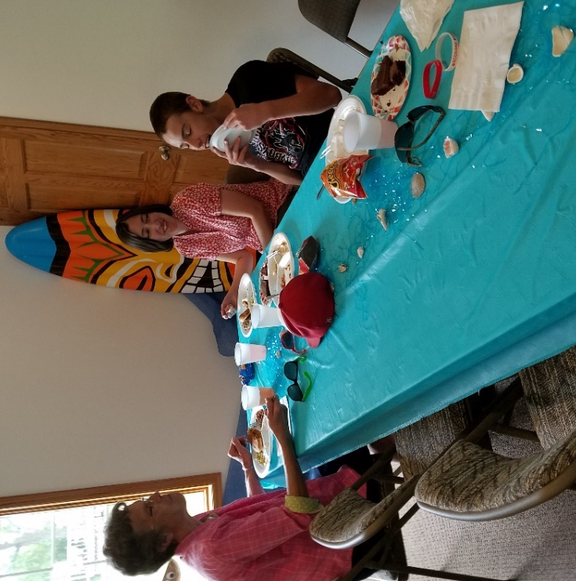

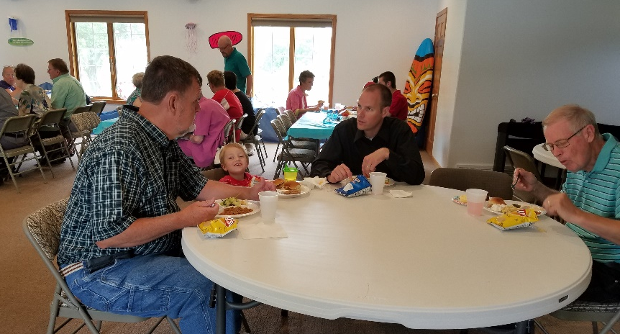
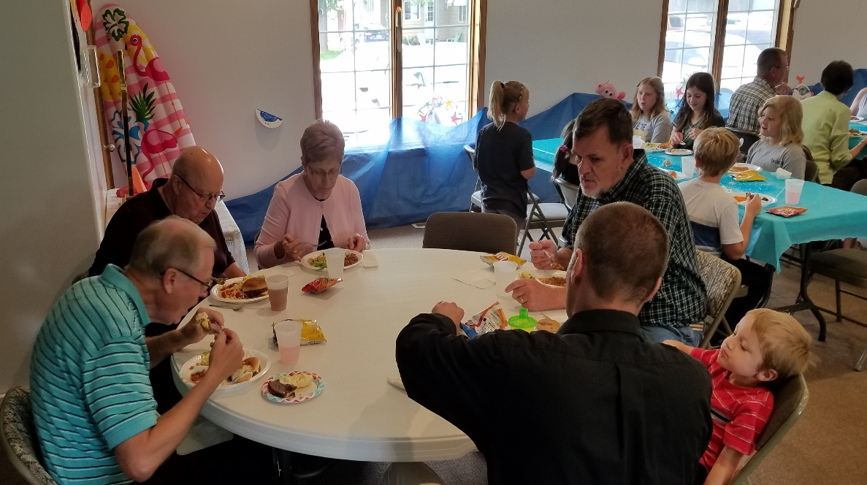
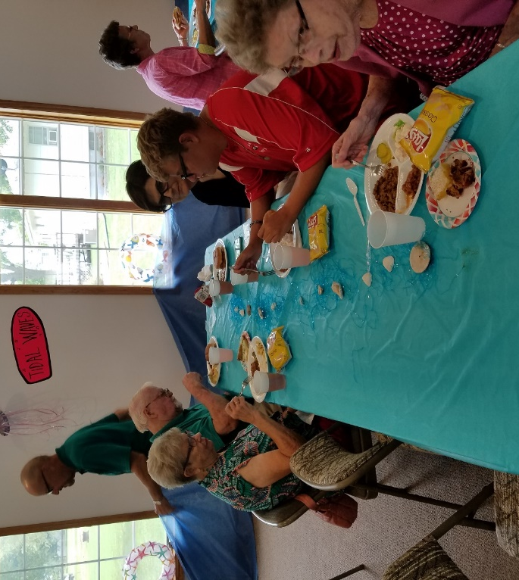
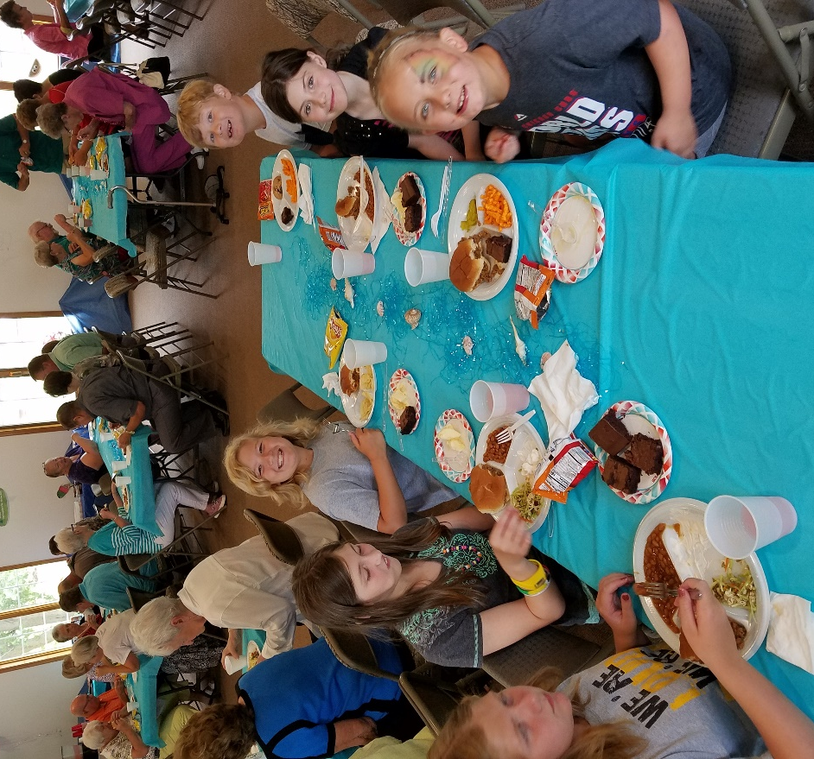

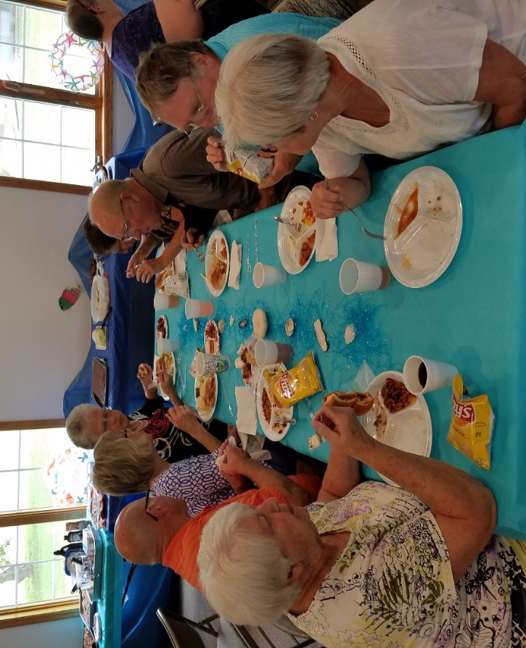

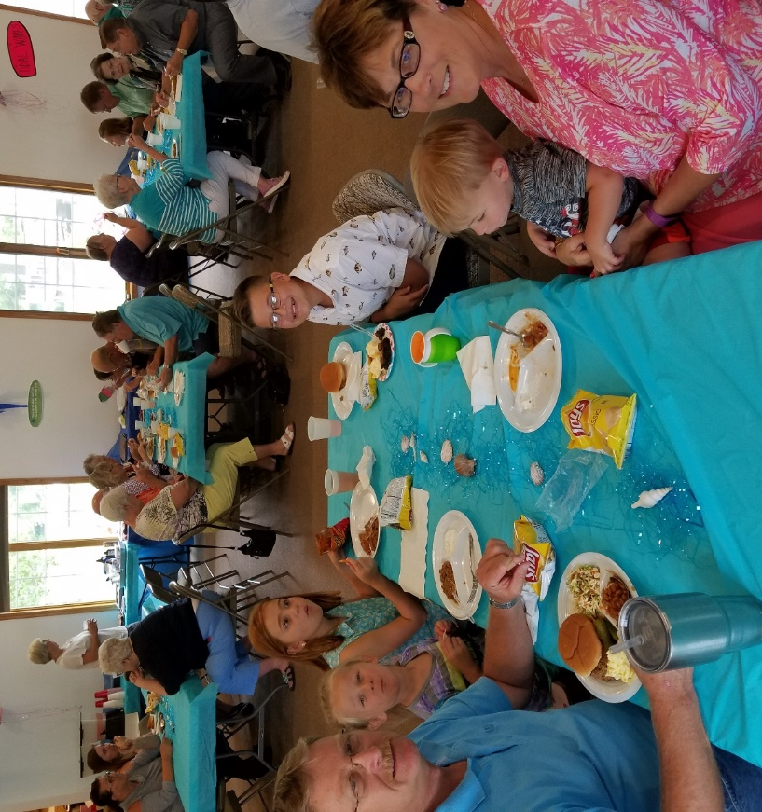

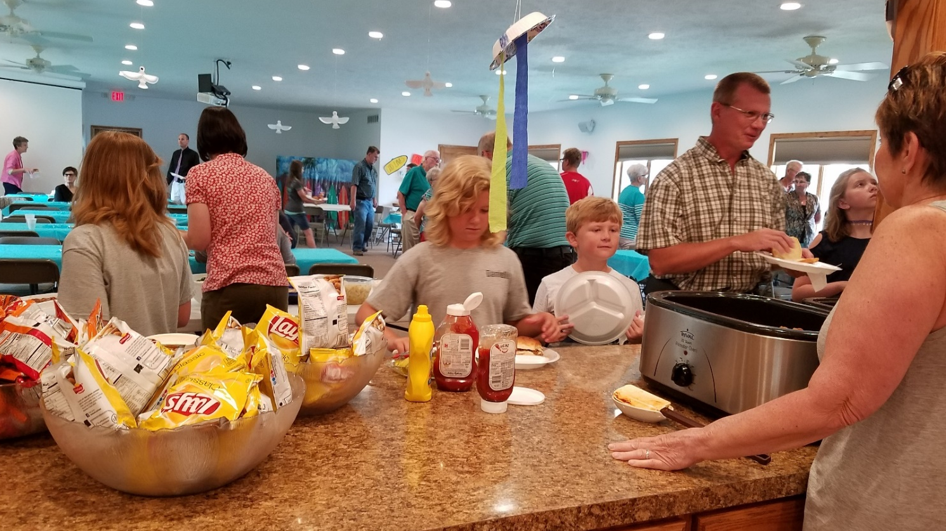

PRAYER LIST:
Our Churches as we continue to transition to a new pastor and for guidance in ministry of love to our community & one another
Our Country, its Leaders, military, police, firemen, health care providers & teachers (wisdom and courage)
Pastor Jason Gutzmer and his family as they transition to our communities
Travel concerns
Work/employment concerns
Victims & families of these senseless and evil shootings
Victims of natural disasters (volcanoes, tornados, hurricanes, earthquakes, mudslides & fires)
Personal Relationships (healing)

Pastor Gideon & Jhona Lyn, Ruthie & Josh as they move to a new community and church

Debbie & Scott Davey
The family of Helen Mueksch
The Hughes family
Rene Gochenour (healing)
Dave Herman (healing & strength)
Ruth Busing (healing & strength)
Keith King (healing & peace)
Cassie Jensen (healing & strength)
Julie & Ben (healing)
Diane Palmer
LaVerne Jackson (health)
Bob King (healing)
Randy Elliot
Robert Hardy (health/healing)
Margaret Hardy (healing)
Dalton Anderson (healing & peace)
Shawn Malony (healing)
Jennifer (Stolz) Small (healing)
Avis Thune (health/healing)
Ceil & Dave Higgins (health/healing & strength caregiver)
Alan Hove (health/healing)
Conner Dowling (health/healing)
Noel Mumm (health/healing)
Jim O’Neill (health/healing)
Darci (Herman) Homan (healing/encouragement)
Jackson Tijerina (son of Amy Holben) (healing/comfort)
Howard Spanton (healing – physical & spiritual)
Rogene Spanton (healing – spiritual)
Janelle Comerford (health/healing)
Heather Nelson (health/healing)
Elaine Krambeck (health/healing)
Ellen Dunn (restore health & well-being)
Helen Dunn (peace & strength)
Lindsay Baronich (healing)
Craig Guttau (healing)
Linda McIntosh (healing)
Donna Hansen (healing)
Elena Carson (healing)
Sharon Johnson (healing)

Please let Ruth Utman or the church office know if you have additions or deletions to make to the Prayer List. 712-645-2893 or rutman@burlingtoncapital.com

If you can’t sleep, don’t count sheep, Talk to the Shepherd

August 2018
Sunday | Monday | Tuesday | Wednesday | Thursday | Friday | Saturday
 | Read & feed | Read & feed | 1  Read & feed | 2  Read & feed | 3  VBS @ Mo. Valley 8-12:30  Read & feed | 4
5 “Communion Sunday”  Modale: 9:00 am  Missouri Valley: 10:30 | 6  Read & feed | 7  SPPRC Meeting  at MV @ 7:00 pm  Modale – BOT meeting @7pm  Read & feed | 8  MV UMW @ 1:30 pm Connie Livermore-hostess  Mo Valley Church Council Meeting at 7PM  Read & feed | 9  Read & feed | 10  Read & feed | 11
12  Modale: 9:00 am  Missouri Valley: 10:30 am | 13  SPPRC church transition workshop in MV @7PM  Read & feed | 14  Quilts for comfort  6-9pm  Read & feed | 15  MO UMW  7:00 pm  At Modale UMC  Read & feed | 16  Read & feed | 17  Read & feed | 18
19  Modale: 9:00 am  Missouri Valley: 10:30 am | 20  Read & feed | 21  Modale UMC Church Council Meeting @ 7pm  MV- Piecemakers Quilt 7-9pm  Read & feed | 22  MV Community Table  at 5:00 PM  MV Trustees @6:30 pm  Back to school | 23 | 24 | 25
26  Modale: 9:00 am  Food & Fellowship after Worship  Missouri Valley: 10:30 am | 27 | 28 | 29  Luncheon 11-1:30pm  Missionary, Doug Williams to speak in MV | 30 | 31

UNITED METHODIST CHURCH NON-PROFIT ORGANIZATION
308 E. SUPERIOR ST. U.S. POSTAGE PAID
MISSOURI VALLEY, IA. 51555 Permit Number 6

RETURN SERVICE REQUESTED

